Qiskit Fall Fest 2026: Basic Track Hackathon Report
Team: Shannon Canon
Member: Ayank Aryan
Date: October 17, 2026

- Executive Summary
This report benchmarks the fidelity of a 2-qubit Bell state across three distinct quantum hardware architectures: a 2016-inspired 5-qubit model, a contemporary heavy-hex 127-qubit model, and a hyperbolic-inspired topology. I evaluated baseline hardware noise and implemented a 3-qubit error detection strategy using an ancilla parity check with post-selection.

- Methodology & Baseline Execution
We simulated the physical execution of a Bell state on local AerSimulator backends injected with custom noise models. Expectation values were extracted manually from raw shot dictionaries (1,024 shots) across the XX, YY, and ZZ measurement bases to bypass the memory limits of statevector estimators on 127-qubit graphs.
Bell fidelity was verified with a 95% confidence interval using the mathematical condition $F-2σ_{F}>0.5$ where standard statistical error was calculated as $σ_{PP}=\sqrt{\frac{1-<PP>^{2}}{N_{shots}}}$
- Core Comparison Table (Task 4)
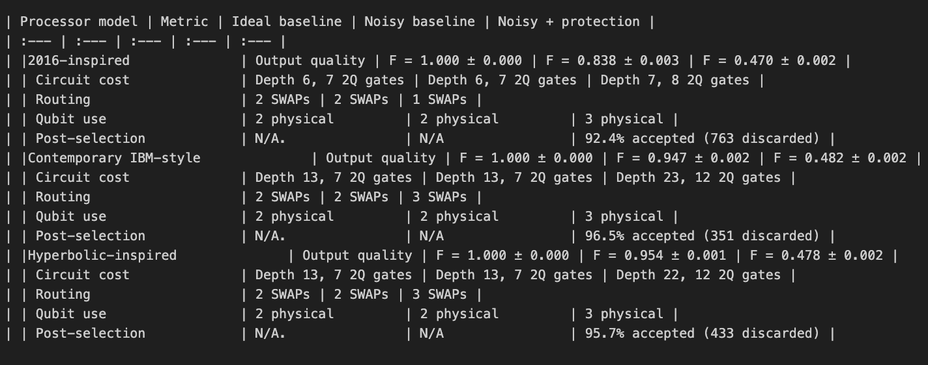

- Protection Strategy Analysis (Task 5)
The implementation of the 3-qubit ancilla parity check revealed a critical threshold challenge in near-term quantum error mitigation. Across all three hardware topologies, applying the post-selection filter caused the Bell fidelity to crash below the 0.5 entanglement verification threshold.
This degradation occurs because the physical routing overhead required to execute the parity check injects more noise into the system than the filter is capable of removing.

- Design Recommendation for Future Cloud Quantum Systems
My recommendation for the future quantum hardware architectures would be to prioritise higher degree connectivity topologies. The importance of this is clearly visible in my simulation where due to the depth increasing from 13 to 22, and the number of swaps increasing the fidelity rate dropped below the standard benchmark because of the increased noise in the system due to the increase in the number of gates involved. Specifically, quantum compilers must insert SWAP gates to bridge non-adjacent qubits, and every single SWAP requires 3 noisy CNOT gates. While the baseline Contemporary circuit already required 2 SWAPs (7 total CNOTs), the protection strategy required an additional SWAP and two extra parity CNOTs, bringing the total to 12 CNOTs. This nearly doubles the number of noisy two-qubit operations, and the cumulative decoherence introduced by these gates destroys the Bell state prior to measurement, rendering the post-selection filter useless.
Hence, the above idea would really help in removing these types of errors from the system.

